EEG(electroencephalogram)

-Sparsh Gupta

Basic terminology

EEG uses international 10-20 system which is applied to our head and then recorded. It is the standard system for locating the electron in our head. So there are 4 position in our head through which information is easily transferred between the patient. So the first position is on the bridge of the nose refer to as “Nasion” and second position at the back of the head known as “Inion”. Then we have the other two positions on the either ears called as “Two Pre-Auricular points”. Consider the diagram the dotted line connecting the Nasion and Inion is divided in the ratio of 10 and 20. Similarly the dotted line connecting the Two pre-auricular points is divided in the same ratio. The marks are added at every ratio. The circle connecting the 4 outer points are divided into 10%. Then the paracedual measurements are made with 25% increments.

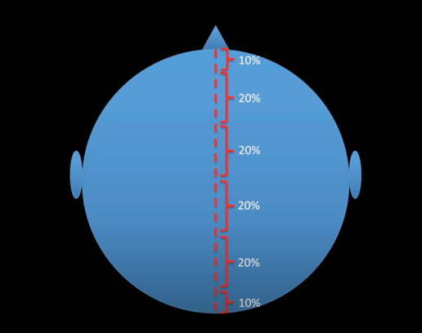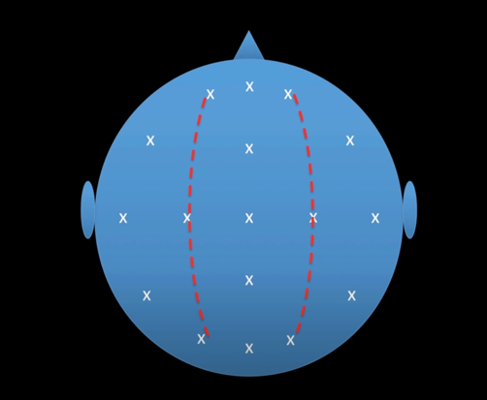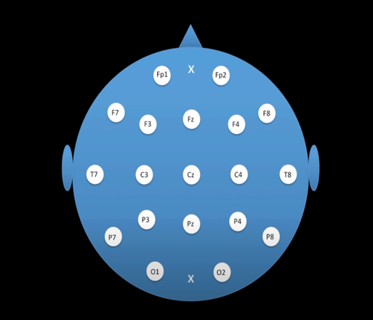

Img1.1

How EEG is recorded?

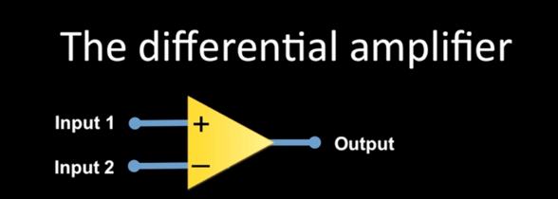

• A differential amplifier filters out ambient electromagnetic noise, allowing us to focus on the actual brain wave. The differential amplifier takes two input and displays the output as difference of two input. This is useful in displaying small electrical signals. An example is given below:

: 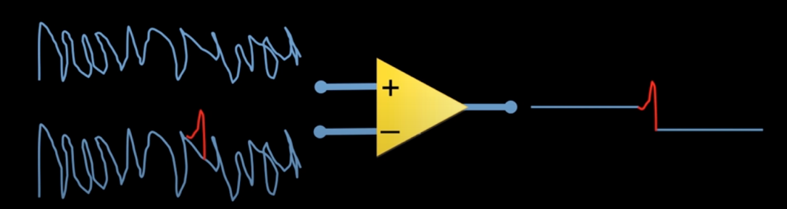

Polarity rules:

* EEG tracing is always relative (not absolute).
* An upward deflection in a channel means input 1 is negative with respect to input 2, while a downward deflection means input 1 is positive with respect to input 2.

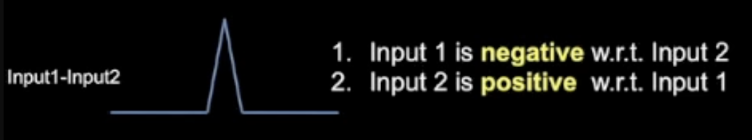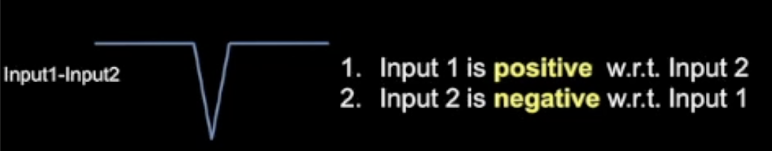

Let’s explain it with one example:

As we can see that Fp8 -F8 has a downward deflection, so we write its polarity by polarity rules. The same can be done for F8-T8. Hence we can see that F8 is relatively negative in both channels, this means F8 is probably negative in an absolute sense. This is known as “Phase Reversal”.

Polarity of an EYE

When we blinks our eye, our eye balls moves up. Fp1 and Fp2 would have the highest positive charge from the electropositive cornea. So now Fp1 would be higher positive charge than F3. So this should show a downward

deflection. Similarly in other cases too deflection.

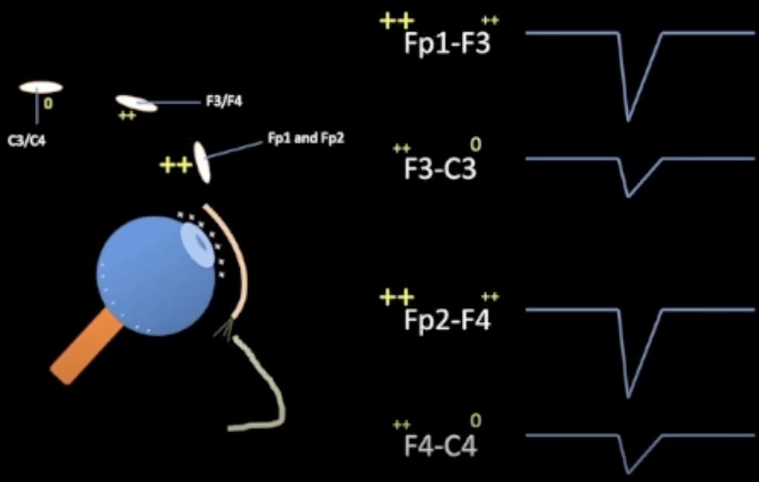

Horizontal movement of an eye.

Lets us suppose it moves to right side then the F7 would have highest positive charge. So again we will compare different channels and examine whether the channels is downward or upward deflection. We can confirm it with sample recordings.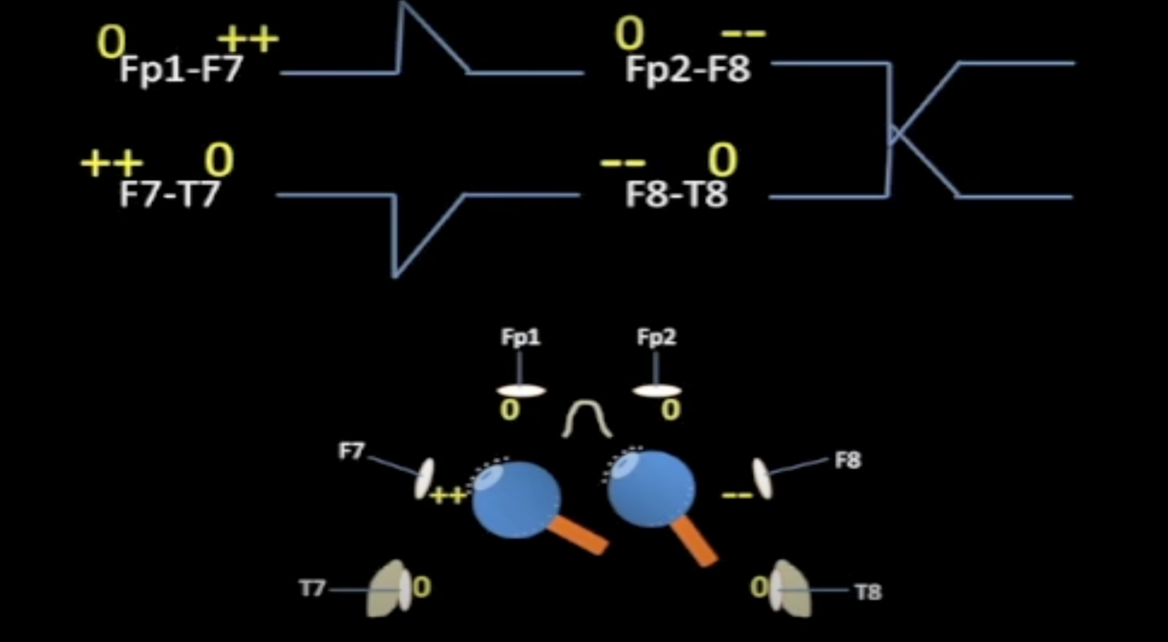

 A useful shortcut to determining the direction of horizontal eye movements is to look carefully at the deflection of the baseline in the two most anterior temporal leads on one side and the other. If the deflections move away from each other, creating space, the eye movement is likely in that direction.

A small spiky waveform just before the eye movement, known as a lateral rectus spike, which is sometimes mistaken for an epileptiform discharge. This artifact is caused by the contraction of the lateral rectus muscle.

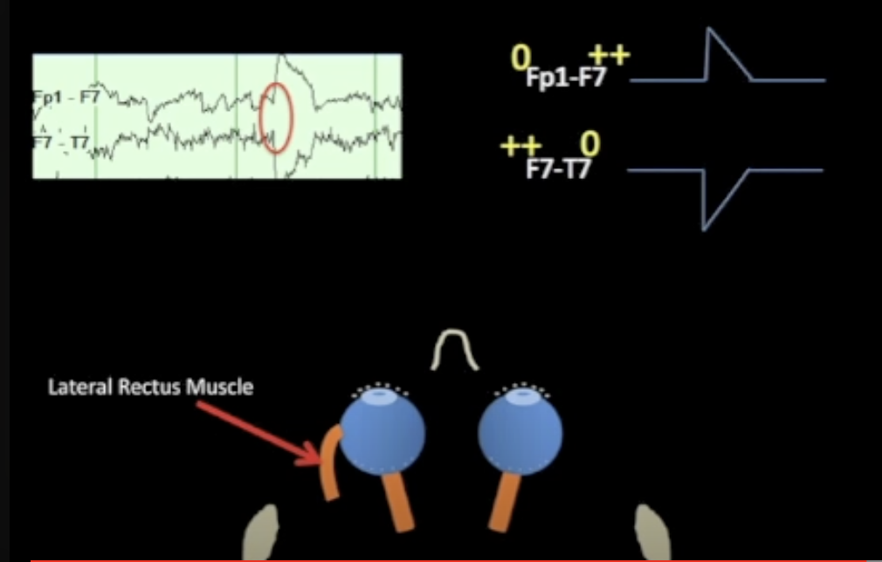

Different types of EEG Montages

* **Bipolar:** are one of the most commonly used montages in EEG interpretation. They are based on the principle of comparing a single EEG electrode tracing to its adjacent neighbour.

It is of 2 types: The **anterior-posterior bipolar** montage is a common bipolar montage that compares electrodes along the temporal aspect of the head, generating a chain of electrodes.

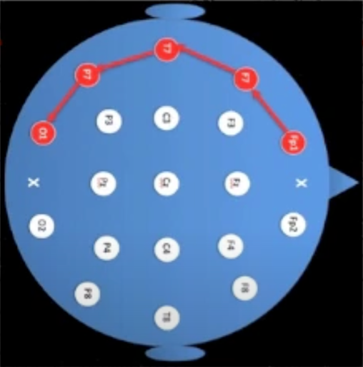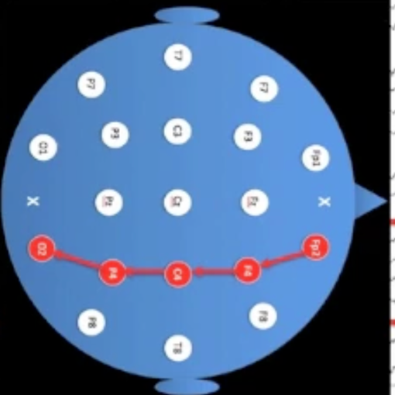

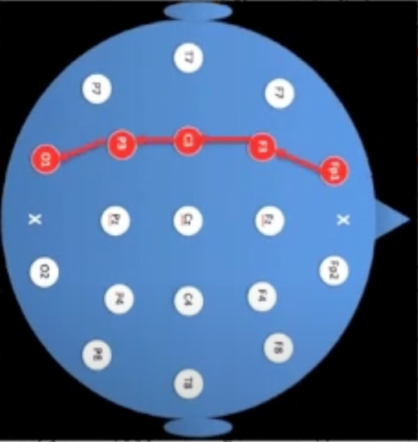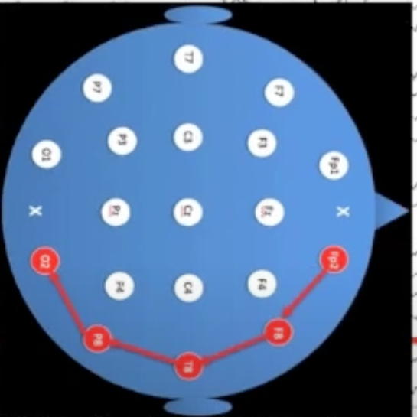

Then we have **transverse bipolar montage**, which is arranged as if looking at the top of the head and the patient is facing upward. This montage is particularly good at focusing attention on the center of the head, where many sleep transients are maximal.

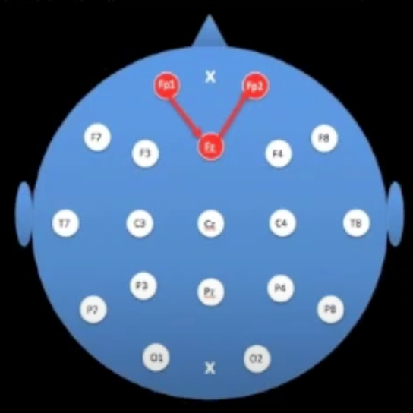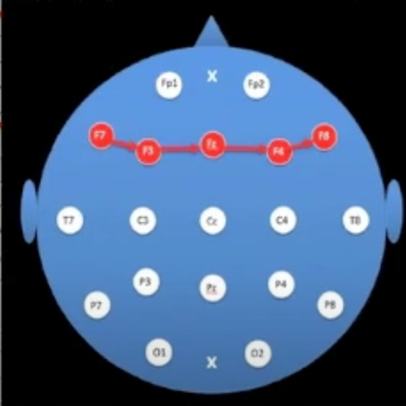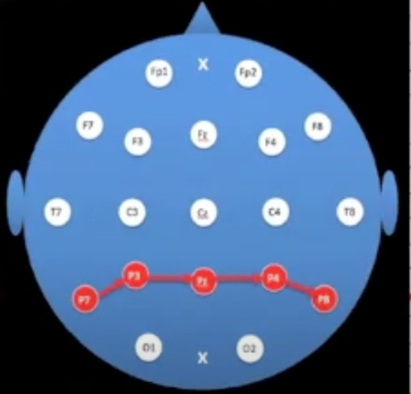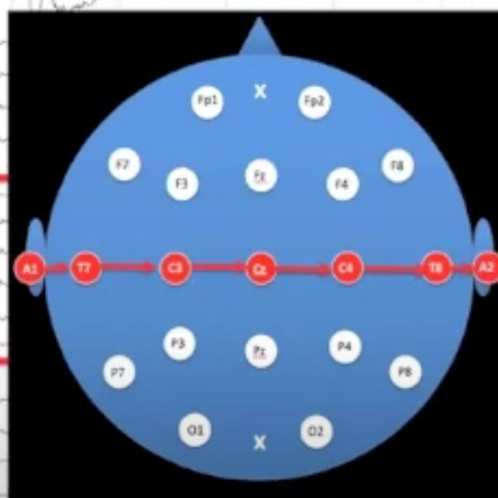

**Common reference montage:** compare the signal at every electrode position on the head to a single common reference. The most common reference montage is the CZ montage, which compares every electrode on the head to the CZ electrode. This montage is arranged in the same way as the anterior-posterior bipolar montage, with left temporal, left parasagittal, midline, right parasagittal, and right temporal chains.

**Average reference montage** compare the signal at each position in the head to the average of the rest of the head. This montage is useful for reducing the effect of distant electrical activity on the EEG recording. We neglect Fp1,Fp2,O1,O2 because these were easily affected by IM movement.  However, it can be affected by reference contamination, which can lead to misleading findings.

**Reference contamination:** Suppose we have the maximal at the Cz,C3,C4 then it will create the negative charge along center. Hence it acts as changing the average of rest of the heads.

Hence it appears the downward deflection of any point on head.

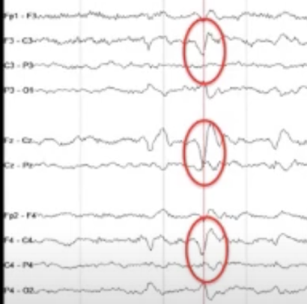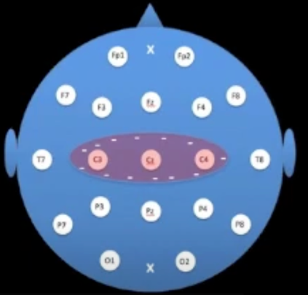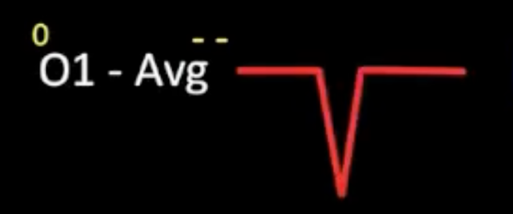

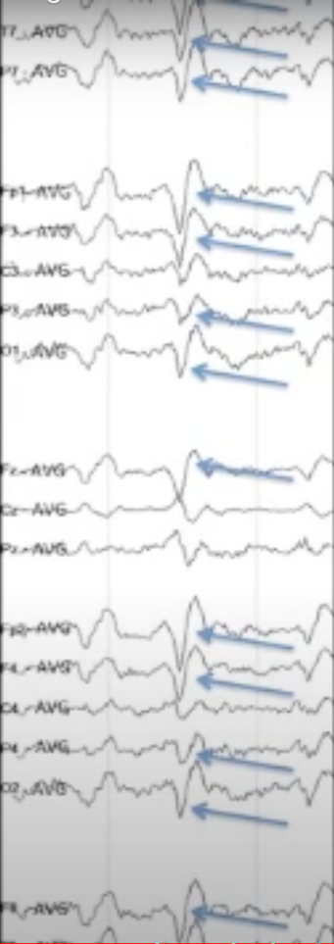

To overcome from this problem we use Laplacian montages.

**Laplacian montages**: a less commonly used montage that compares one electrode position to an average of its nearest neighbours. This montage is useful for reducing reference contamination and focusing on focal discharges.

Understanding EEG montages is crucial for interpreting EEG data accurately. Bipolar montages are useful for comparing adjacent electrodes, common reference montages are useful for comparing the signal at every electrode position to a single common reference, average reference montages are useful for reducing the effect of distant electrical activity, and the Laplacian montage is useful for reducing reference contamination and focusing on focal discharges.

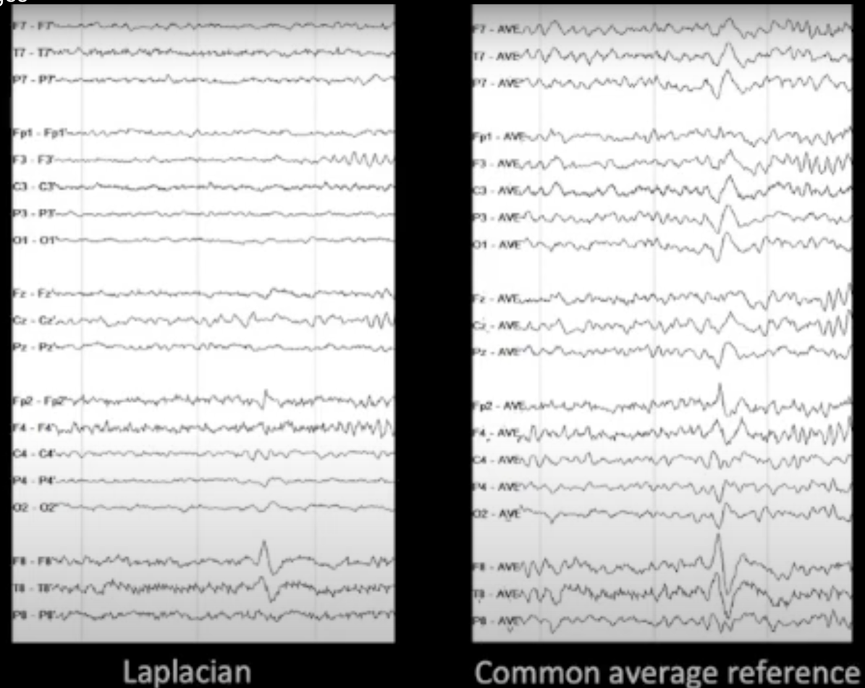

* EEG waveforms are divided into frequency bands: delta, theta, alpha, and beta.
* Alpha waveforms have a frequency of 8-13 Hz and are visible in the back of the head.
* Theta waveforms (4-7 Hz) are slightly slower than alpha and can be seen in the parietal region.
* Delta waveforms (less than 4 Hz) are slower than theta and are associated with sleep.
* Beta waveforms are high-frequency (13-30 Hz) and can indicate anxiety or other cognitive states.
* **Low frequency filter** do not completely eliminate frequencies below the cut off; they diminish them. It has 3 zone:(0-0.3)hz =No signal,(0.3-3)=diminished signal,(3-…)=full signal.

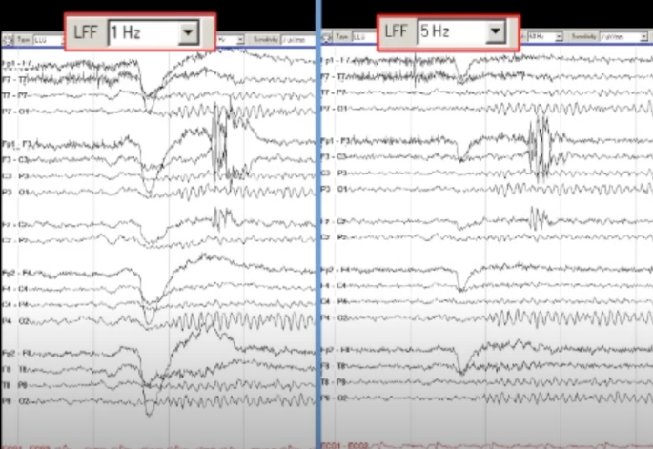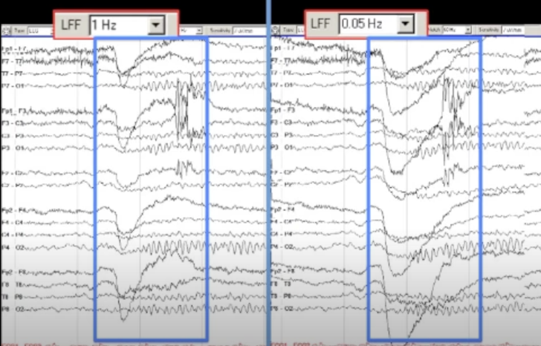

**High frequency filter:** High-frequency filters allow low frequencies to pass through without filtering.it also has 3 zones:(0-30)=”low pass filter”,(30-100)=”diminished signal”,(above 100)=”No signal”.

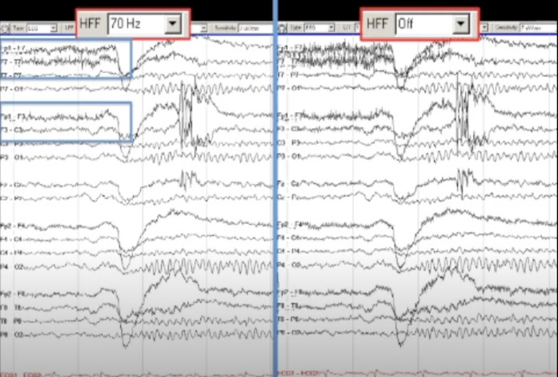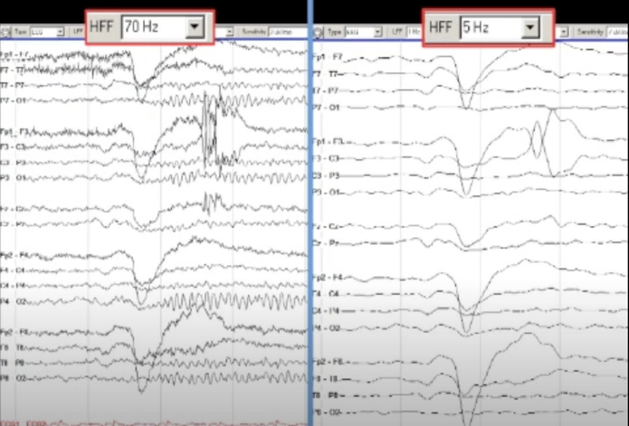

**Notch filter :** it helps us to deal with the contaminated signal produced by high impendence of any F3(an be anything.

.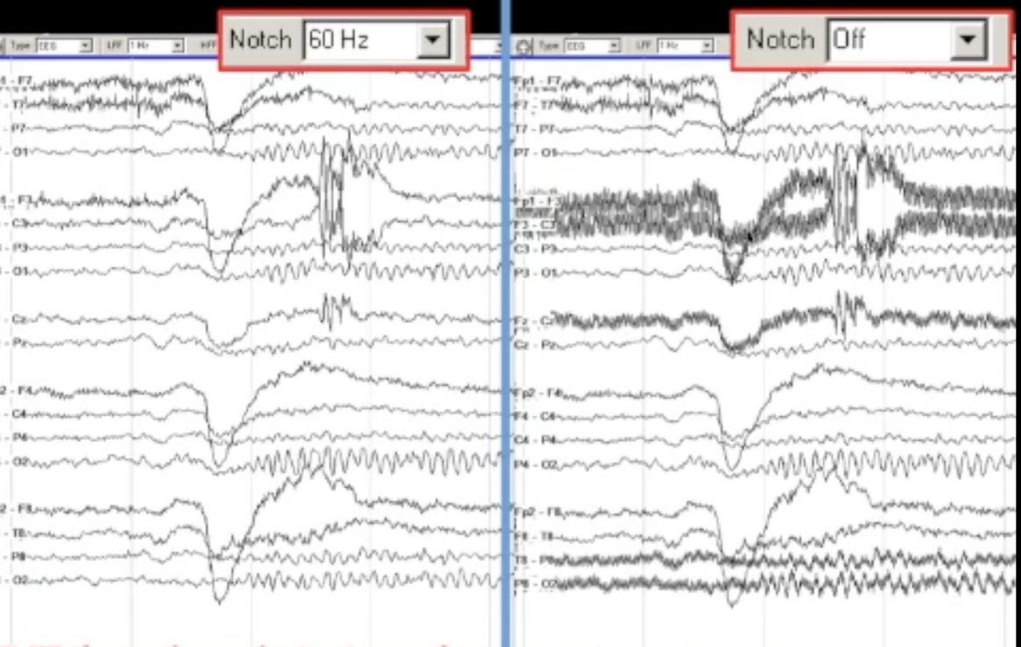

Sensitivity in EEG recordings represents the true amplitude of brain waves on the screen. lower sensitivity generates the higher amplitude on the screen and vice versa.

The time base setting determines how much time is represented on a single page of the EEG recording. A slower time base can make the EEG appear slow

And vice versa.

NORMAL AWAKE EEG

* A low frequency filter of 1 Hz and a high frequency filter of 70 Hz are appropriate for normal wakefulness
* The notch filter should be off to avoid missing important data about the technical quality of the recording
* Normal sensitivity for reading adult EEG is 7 microvolts per millimetre
* The main segments of the EEG to focus on a relatively high frequency oscillating pattern (alpha rhythm) .
* The alpha rhythm is reactive, with higher voltage when the eyes are closed and lower voltage when the eyes are open.

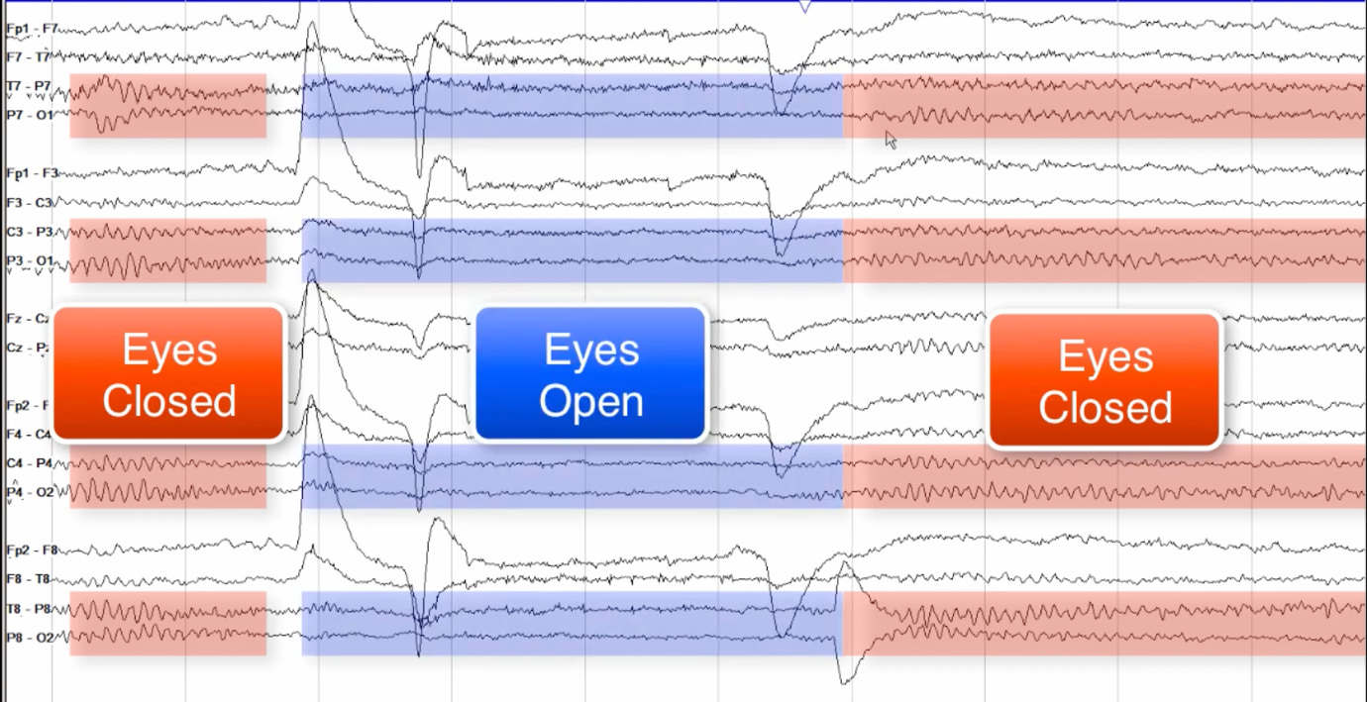

* We will use scale legend to measure the amplitude.so the amplitude is 40-50uV
* The symmetry of the alpha rhythm should also be considered, with a normal level of asymmetry being less than 50% on a referential Montage.
* The alpha rhythm is generally maximal in the posterior head regions, particularly the occipital electrode contacts.
* It Is fairly constant in an individual(can slow with older age)
* Other normal variants include Alpha squeak, mu rhythm, and Lambda waves.
* **Alpha squeak** is a faster rhythm than the normal alpha rhythm, approximately twice as fast, before returning to the normal baseline.
* **Lambda waves** are generated by inspection of complex visual patterns during routine EEGs and are most prominent when the eyes are open.
* **Mu rhythm** is generated by the sensory motor cortex at rest and is most prominent when the patient has their limbs at rest.
* **Lambda waves** are blocked by eye closure.